See SolarWinds webinar notes at the end of this.

Activity {Help and Searching for cmdlets} | Code and Notes
Determine version, edition (i.e., Core, Desktop) of Windows PowerShell on a computer. | $PSVersionTable
Installing various versions of PowerShell (product documentation) | https://aka.ms/pscore6get  The traditional PowerShell executable is PowerShell.exe.  The PowerShell Core executable is Pwsh.exe.  PowerShell and Core can co-exist.
Getting help. | Get-Help displays all help content.  Get-Help Get-ChildItem displays all help content  Get-Help *process* It accepts wildcards for cmdlet names.  Get-Help Stop-Process -Examples  Get-Help Stop-Process -Full to see the most complete help information for that cmdlet  -Show Window help shows up in a separate window  -Online Online version of the Help topic  -Parameter ParameterName  -Category Displays help only for certain categories of commands  Get-Help about* Provides a huge list of “about_” help topics regarding the PowerShell scripting language, operators and more (global shell techniques and features). You can then reference one of those help topics, such as:  Get-Help about_Workflows
Update help | Update-Help
Download help to an alternate, user-specified location | Save-Help
Getting the name of cmdlet. | Get-Command Lists every installed cmdlet, alias, function, filter, script, and application installed on the computer, and retrieves information such as name, category, version, and even the module that contains it.  You can also reverse this and find out what Module a cmdlet is hosted within.  Get-Command -Type cmdlet CmdletName  Get-Command SomeCommandName imports the module that contains the command.  Get-Command *process* Wildcards also supported. Lists every cmdlet with “process” in the name.  Also: Find-Command
Filter portions of the cmdlet name using based on an attribute of the cmdlet | -Module ModuleName Lists only cmdlets in the specified Module  -Noun  -Verb  Get-Command -Noun event* -Verb Get
Comment code | Use # for a single line comment and <# stuff #> as a block comment

Activity {Modules} | Code and Notes
Modules are groups of cmdlets that are packaged together, a container of sorts. | To use a cmdlet within a Module the Module must be imported (loaded)
Retrieve list of imported Modules in the current session or that can be imported from the PSModulePath | Get-Module  Get-Module -ListAvailable  Get-Module -Name ModuleName
Load a Module into memory (after it has been installed) | Import-Module Modulename
Update a Module | Update-Module -Name ModuleName  A bunch of other parameters exist.
The PowerShell Gallery | The central repository for sharing and acquiring PowerShell code including PowerShell modules, scripts, and DSC resources.  https://powershellgallery.com  The PowerShell Gallery uses PowerShellGet Module which contains cmdlets for finding and installing modules, scripts and commands.  Use Get-InstalledModule to get a list of modules on the computer that were installed by PowerShellGet.  You may have to run Set-PSRepository to trust PowerShellGet as a repository.  Another source of code is the Script Center
To search for modules within the PowerShell Gallery | Find-Module
To search for scripts within the PowerShell Gallery | Find-Script
Install a Module  You can also uninstall a Module, but not referenced in this document. | Install-Module -Name ModuleName
A number of cmdlets have aliases. | Get-Alias Returns all defined aliases.  Get-Alias di* Wildcards are available.
Aliases can be added and removed, but, they are not saved between PowerShell sessions.cls | New-Alias -Name “AliasName” morestuff_as_necessary  Get-Alias -definition Remove-Item reverses the process and find an alias (or multiple aliases) assigned to a cmdlet.
To open a window that displays either a list of commands or the parameters for a specific command. | Show-Command -Name cmdletName  You can then supply any values in the form that apply and/or are required and click on the “Run” or “Copy: buttons.

Activity {Module Discovery} | Code and Notes
This lists some of the Module categories for Windows administration
Active Directory | - User Management  - Group Management  - Computer Object Management  - OU Object Management  - GPO Management  - Various AD object Management areas  - Move / New / Set / Remove / Sync…
Networking | - Managing IP Addresses  - Managing Routing  - Managing DNS Clients  - Managing Windows Firewall
Server Manager | Windows Features
Hyper-V | Many cmdlets available
IIS Management

Activity {Pipelines} | Code and Notes
A pipeline is one or more commands. Consider that each cmdlet/command is its own pipeline. | Typical patterns are:  Get | Set, Get | Where, or Select | Set  “Where” is an alias for Where-Object and “Select” is an alias for Select-Object.
The output of a cmdlet is a collection of objects, or Object for short. | The structure of an Object is sort of like a table.  Each row is an “Object”.  Each column is a “Property” of the Object.  The rows are called a “Collection”.
Members are the various components of an Object and include: | - Properties  - Methods (perform some kind of action)  - Events  The default on-screen output does not include all of an Object’s properties as some Objects have hundreds.
To list the Members of an Object: | Get-Member Lists all Properties, Methods, and Events  (alias, gm)  Get-Service | Get-Member
To page the output of a cmdlet: | Use | More which shows only one page of output, which does not work within the PowerShell ISE, only the console. A substitute to | More is Out-Host.  From there hit:  Spacebar Ü pages through the output.  Enter Z progresses through the output one line at a time.
Formatting Pipeline output.  Cmdlets have a default output and these cmdlets can override the default output. | | Format-List  (alias, fl), each Property on a separate line for each Object. Each object will have its own list. Particularly useful when a command returns a large number of Properties that would be hard to read in table format.  | Format-Table  Useful for displaying Properties of many Objects at the same time and comparing the Properties. Also provides  -AutoSize,  -HideTableHeaders, and  -Wrap.  | Format-Wide two column, single Property output. (alias, fw-all),  | Format-Custom requires creation of custom XML files  Each of these accepts the -Property parameter where one supplies a comma-separated list of property names.

Activity {Selecting, Sorting, Measuring} | Code and Notes
Override the default sort output | | Sort-Object two column, single Property output. (alias, sort,  Get-Service | Sort-Object -Property Name - Descending  Get-Service | Sort Name – Desc  Get-Service | Sort Status, Name  Get-Service | Sort-Object Status, Name |fw -GroupBy Status  See also Group-Object which gives more grouping control.  Other parameters apply.
Aggregations can be applied to output | Get-ChildItem -File | Measure -Property Length –Sum  –Average -Minimum -Max
Select a subset of the Objects {rows} passed along the pipeline using Select-Object | Get-Process | Sort-Object -Property VM | Select-Object -First 10  Get-Process | Sort-Object -Property CPU -Descending | Select-Object -First 5 -Skip 1  First | Last | Unique | Skip | Index | Unique  (alias, select)  Sort-Object is used to control the object order prior to object selection.
Select a specific set of Object Properties {columns} passed along the pipeline using Select-Object which requires -Property | Get-Process | Select-Object -Property Name, ID, VM, PM, CPU | Format-Table comma delimited list of Properties  Get-Process | Sort-Object -Property CPU -Descending | Select-Object -Property Name, CPU -First 10 the ten processes using the most CPU.
When using the PowerShell console you can break up a command over multiple lines and obtain an “extended prompt” | …then hit Z when the code is complete.
Calculated columns through hash tables

Activity {Controlling Pipeline output with Comparison Operators} | Code and Notes
 | The operators are case insensitive with strings. Prefix each of the operators below with “c“, like -ceq for a case sensitive version.
Equal to | -eq
Not equal to | -ne
Greater than | -gt
Less than | -lt
Less than or equal to | -le
Greater than or equal to | -ge
For pattern matching use the
-Like (or -cLike) operator with wildcards ? and *
There are other, more advanced operators | -in  -contains  -as  -match and -cmatch
Another type of filtering can be accomplished with  Where-Object (alias Where)  There’s a basic (single comparison) and advanced form of usage.  There’s an extensive parameter list. | Get-Service | Where Status -eq Running
The advanced usage requires a filter script.  The filter script runs one time for each Object that is piped into the command. | $PSItem (or $_ earlier versions of PowerShell) is a special variable created by Windows PowerShell. It represents whatever Object is piped into the Select-Object command.  The following are four equivalent commands:  Get-Service | Where Status -eq Running  Get-Service | Where-Object -FilterScript { $PSItem.Status -eq ‘Running’ }  Get-Service | Where { $PSItem.Status -eq ‘Running’ }  Get-Service | ? { $_.Status -eq ‘Running’ }  Combining criteria (each expression criterion must be complete):  Get-EventLog -LogName Security -Newest 100 |  Where { $PItem.EventID -eq 4672 -and $PSItem.EntryType -eq ‘SuccessAudit’ }  If the Property interrogated is already Boolean other operators are available.  Get-Process | Where { $PItem.Responding -eq $True } or  Get-Process | Where { $PItem.Responding }  Get-Process | Where { -not $PItem.Responding } negation

Activity {Enumerating Objects in the Pipeline} | Code and Notes
Definition: Enumeration is the process of performing a task on each Object, one at a time, in a collection. | Enumeration is not always required, as seen below...  Get-Process -Name Notepad | Stop-Process or  Stop-Process -Name Notepad
The ForEach-Object command performs enumeration.  There is a basic and advanced syntax. Basic syntax can only access a single property.  The requirement for enumeration seems to be reduced with newer PowerShell commands | Two common aliases are ForEach and %.  Three equivalent commands...(The -File Object type, System.IO.FileInfo has a method named Encrypt)  Get-ChildItem -Path E:\Data -File | ForEach-Object -MemberName Encrypt  Get-ChildItem -Path E:\Data -File | ForEach Encrypt  Get-ChildItem -Path E:\Data -File | % Encrypt
The output of a cmdlet is a collection of objects, or Object for short. | The structure of an Object is sort of like a table.  Each row is an “Object”.  Each column is a “Property” of the Object.  The rows are called a “Collection”.

Activity {Sending Pipeline data as output} | Code and Notes
Output to a File | Out-File (aliases > and, >>) accepts input from the pipeline. The output appears just as it would on screen. This is not the same as converting or exporting objects. This option is mostly for human consumption and not for reading back into PowerShell.  This terminates the pipeline.  > directs to a file, overwriting if it already exists  >> appends to an existing file.  Get-Service |  Sort-Object -Property Status, Name |  Select-Object -Property DisplayName, Status |  Out-File -FilePath ServiceList.csv
Convert Output to CSV | Converts the output to CSV and the data remains in the pipeline. CSV output produces column headers. There is also an Import-CSV cmdlet.  Get-Service | ConvertTo-CSV | Out-File Services.csv  Export commands, like Export-CSV, perform two operations: converting the data and then writing to external storage.  Get-Service | Export-CSV Services.csv
Convert Output to XML | ConvertTo-CliXML .The data remains in the pipeline.  Export-CliXML
Convert Output to JSON | ConvertTo-JSON .The data remains in the pipeline.
Convert Output to HTML | ConvertTo-HTML .The data remains in the pipeline.  Output can be controlled along with:  -Head  -Title  -PreContent content to appear before the table or list  -PostContent content to appear after the table or list
Additional output options | Out-Host more output control such as with -Paging  Out-Printer sends output to your default printer.  Out-Gridview interactive window that allows you to sort, filter and copy (but not save).

Activity {Understanding How the Pipeline Works} | Code and Notes
Pipeline parameter binding | This command…  Get-ADUser -Filter {Name -eq ‘Dan DeLion’} | Set-ADUser -City Seattle  …the Set-ADUser cmdlet actually has two parameters passed to it, the output of Get-ADUser and-City.  “When you connect two commands in the pipeline, pipeline parameter binding takes the output of the first command and decides what to do with it. The process selects one of the parameters of the second command to receive that output. Windows PowerShell has two techniques that it uses to make that decision.  ByValue always attempted first.  ByPropertyName used only when ByValue fails.  The ability to accept pipeline output is part of the definition of the parameter within the cmdlet code. Use Get-Help whatevercmdlet -Full …to determine the pipeline input capability of each parameter. See screenshot below.  A single command can have more tha one parameter accepting pipeline input x but each parameter must accept a different kind of object.
 | There’s more content to this module.

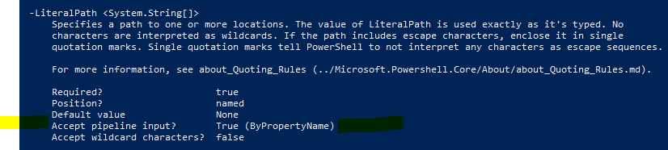

Activity {Using PSProviders and PSDrives} | Code and Notes
A PSProvider, or Provider presents data as a hierarchical store. | In managing IIS I could use an IIS specific cmdlet, like Get-WebSite or a more generic command like Get-ChildItem IIS:\Sites
To list the available providers, and, the capabilities of each provider | Get-PSProvider lists the providers in the current session, their capabilities, and their “drives”.  Get-PSProvider SomeProvider lists the above details for the specified Provider.
Viewing help of a Provider | Get-Help ProviderName
A PSDrive, or Drive is a connection to a data store | Get-PSDrive to see a list of available drives.  New-PSDrive used to create temporary and persistent mapped network drives.  Drive names do not include a colon Drives contain Items.  Items contain child items and properties.
These drives are always available | Registry drives HKLM and HKCU  Local hard drives like C  PowerShell storage drives Variable, Function, and Alias  Web Services for Management (WS-Management) WSMan  Environment Variables Env  Certificate Store Cert
Verbs associated with PSDrive cmdlets | New  Set  Get  Clear  Copy  Move  Remove  Rename  Invoke
Commands that manage PSDrive locations | Get-Location displays the current working location  Set-Location sets the current working location  Push-Location adds a location to the top of a location stack  Pop-Location changes the current location to the location at the top of a location stack
To determine the alias mappings one would translate from a command prompt to PowerShell use Get-Alias  or Get-Command.  PowerShell accepts both \ and / as path separators, so beware that Dir /s would not recurse | Dir Dir /s = Get-ChildItem -Recurse  Move  Ren  RmDir  Del  Copy  MkDir  CD
Relevant drive commands | New-Item  Remove-Item  Get-Item Get-Item * = Get-ChildItem

Activity {Using CIM and WMI} | Code and Notes
Get-WMIObject
Get-WMIMethod
Get-CIMClass
Get-CIMInstance
Invoke-WMIMethod
Invoke-CIMMethod

Activity {Using Variables} | Code and Notes
The main limitation of the pipeline is that the process flows only in one direction and it is diffult to perform complex operations. Variables solve this problem. | Ideas:  - Store the name of a log file that you write data to multiple times  - Derive and store an email address based on the name of a user account  - Calculate and store the date of a day 30 days prior to the current day, to identify whether computer accounts have signed in during the last 30 days.
Variables can hold simple data types like strings and numbers and also Objects | There is PSDrive called Variable and use that with  Get-ChildItem like:  Get-ChildItem VariableName: to view Variable names, or,  Get-Variable
Variable name rules and conventions | It’s common to prefix PowerShell variable names with “$”, but only to make them easier to identify.  If variable names include a space the variable name must be enclosed in braces, like ${Log File}
Assign a value to a variable with the = operator and you can also assign command output (single or multiple values) to a variable.  You can also use Set-Variable | $Num = 10  $LogFile = “C:\Logs\log.text”  $User = Get-ADUser Administrator  $Service = Get-Service W32Time
Show the value of a variable by typing its name and hitting Z | $User Z
To empty a variable | $SomeVariable = $null
Variable data types determine available manipulations | Most of the time PowerShell automatically assigns a data type and that mostly works.  Some available data types are:  String  Int 32 bit integer  Double 64-bit floating point value, for decimals  DateTime  Bool stores values of $true and $false.
Force a variable to accept only specific type of content (limitations apply) | [Int]$Num2 = “5”  [DateTime]$date = “January 5, 2020 11:49AM”
View a variables’ type | $date.GetType()

Activity {Manipulating Variables} | Code and Notes
Variables, just as objects, have properties and methods
The simplest method for identifying the properties and methods available for a variable is to pipe the variable to  Get-Member | $LogFile | Get-Member
To browse through the properties and methods for a variable, you can use tab completion by typing the name of the variable appended with a dot. When you press Tab, the properties and methods available for the variable display. | For more information on .NET Framework variable types, refer to “System Namespace” at:  https://aka.ms/krlgav
String variables have only one property,  Length | $LogFile.Length
The following are some of the string variable methods. | Contains(string value)  Insert(int startindex, string value)  Remove(int startindex, int count)  Replace(String value, string value)  Split(Char separator)  ToLower()  ToUpper()
Date Properties | Hour  Minute  Second  TimeOfDay  Date  DayOfWeek  Month  Year
Date Methods | AddDays(double value)  AddHours(double value)  AddMinutes(double value)  AddMonths(int months)  AddYears(int value)  ToLongDateString()  ToShortDateString()  <and more>  $date = Get-Date  $date  $date.DayOfWeek

Activity {Arrays and Has Tables} | Code and Notes
Think of an Array as a Variable that contains multiple values or objects. | A Variable has one value; an Array has more than one value.
One way to create an Array is to create a comma-separated list. | $Computer = “DC-BER”, “WEB-BER”, “VPN-BER”  $Numbers = 787, 2.71, 3.14
Another way to create an Array is from the output from a command. | $Users = Get-ADUser -Filter *  $Files = Get-ChildItem Z:\
Verify whether a variable is an Array by using the GetType() method | If true the BaseType listed will be System.Array.
You can create an empty Array for when you have a loop that adds items to the Array | $NewUsers = @()
You can also force an Array to be created when adding a single value to a variable. | [array]$Computers = “WEB-BER”
Working with Arrays | $Databases (displays all array items)  $Databases[0] (displays an item by its index number, starting at 0  $Databases = $Databases + $SomeOtherDB (adds a new item to the array)  To identify what you can do with the content in an array use  Get-Member such as:  $SQLAgentJobs | Get-Member  To view the properties and methods available for an array rather than its items  Get-Member -InputObject $SQLServers
Working with Array Lists (for when you have to manipulate an array with a large amount of members) | [System.Collections.ArrayList]$computers = “Srv1”, “Srv2”  <There are more details to this topic.>

Working with Hash Tables | Similar to an Array, as it stores multiple items. Unlike an Array a Hash Table uses a unique key for each item.  With a Hash Table as follows (which stores both computer names and IP addresses):  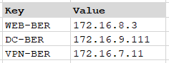  …you access the first item in the hash table either of the two following ways:  $servers.’VPN-BER’ (the hyphen is a special character, which requires single quotes around the key)  $servers[’VPN-BER’]
Define a Hash Table | Similar to an Array, but you need both the key and the value.  - Begins with @  - Keys and associated values are enclosed in braces  - Items separated by a semicolon (when multiple items are on the same line)  $servers =@{“VPN-BER” = “172.16.7.11”; “DC-BER” = “172.16.9.111”}
Adding and removing items is similar to an Array List | $servers.Add(“CertSrv-BER”, “172.16.5.5”)  $servers.Remove(“VPN-BER”)
You can also update the value for a key | $servers.’Web-BER’= “172.16.3.71”)
To view all properties and methods available for a Hash Table | $server | Get-Member

Activity {Basic Scripting} | Code and Notes
 | Script files have a .ps1 extension
You have three options when you right click on a PowerShell script: | - Open (in Notepad)  - Run with PowerShell (the PowerShell prompt closes on completion)  - Edit (opens the script in the PowerShell ISE)
You have three options when you want to run a PowerShell script from the PowerShell prompt | - E:\Scripts\Coolscript.ps1 full path to the script  - \Scripts\Coolscript.ps1 relative path to the script  - .\Coolscript.ps1 reference the current directory
To control whether or not PowerShell scripts can be run on a computer you set the Execution Policy with these options: | - Restricted no scripts can be run  - AllSigned scripts will only if they’re digitally signed  - RemoteSigned downloaded scripts will run only if digitally signed  - Unrestricted all scripts run but with a confirmation prompt  - ByPass all scripts are run without prompts

Activity {Advanced Scripting} | Code and Notes

Activity {Using Background Jobs and Scheduled Jobs} | Code and Notes

Activity {Using Advanced Windows PowerShell Techniques} | Code and Notes

SolarWinds Webcast on 2022-08-17

Ben Miller’s blog post is at DBADuck.com

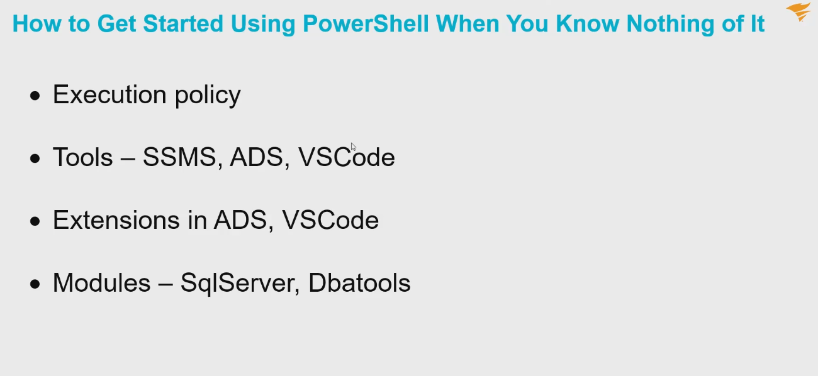
We’ll also add the “importexcel” module.
For Execution Policy you will want “Remote Signed”.

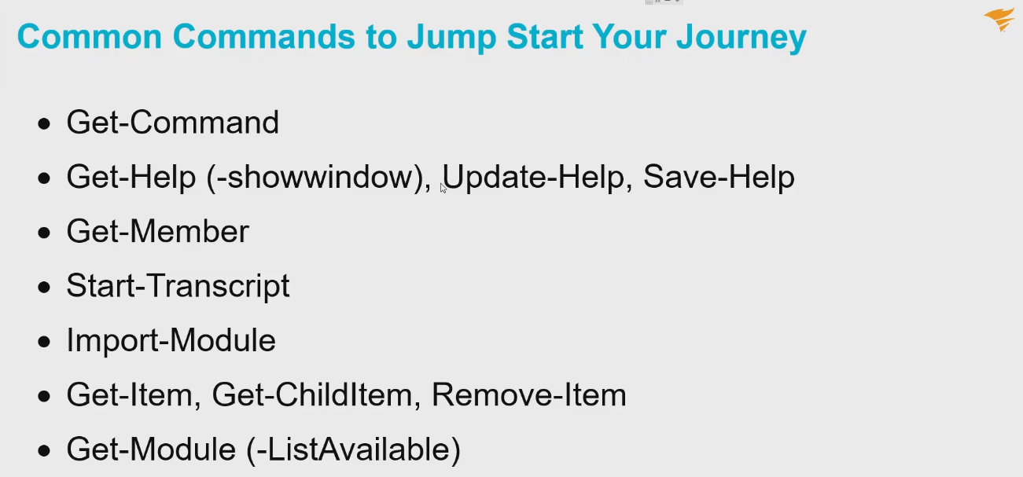
You can save help files to a folder and then transfer that content.
Transcripts allow you to go “headless”. The opposite is Stop-Transcript. An input parameter to Start-Transcript is a path.
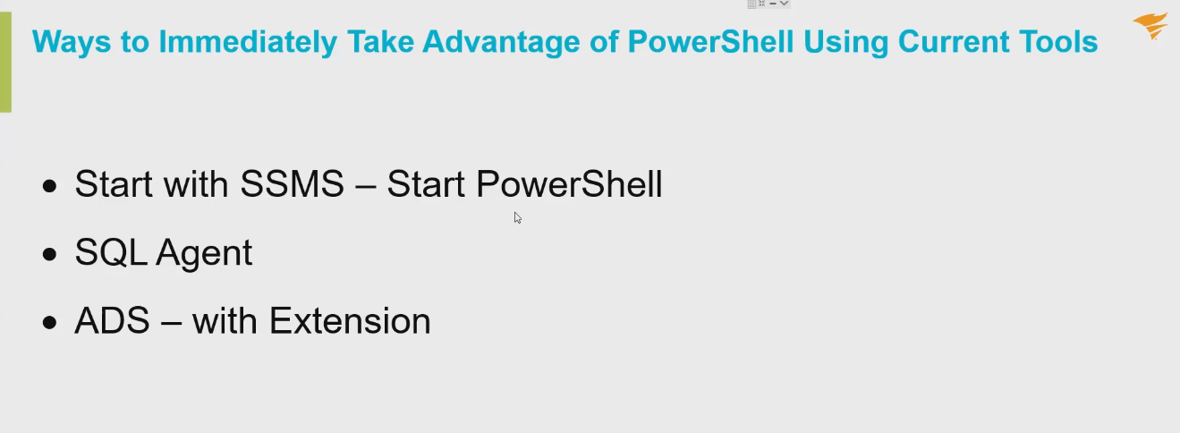
Below – Azure Data Studio
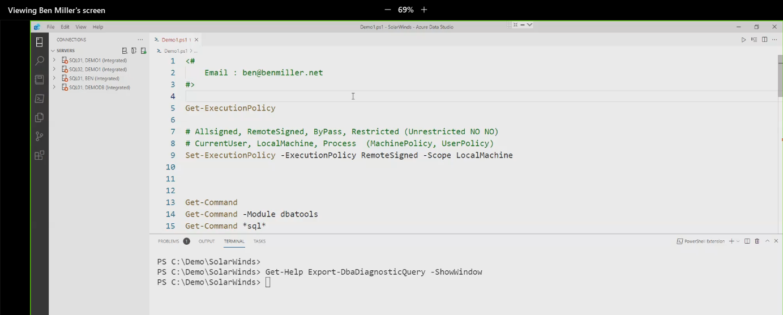

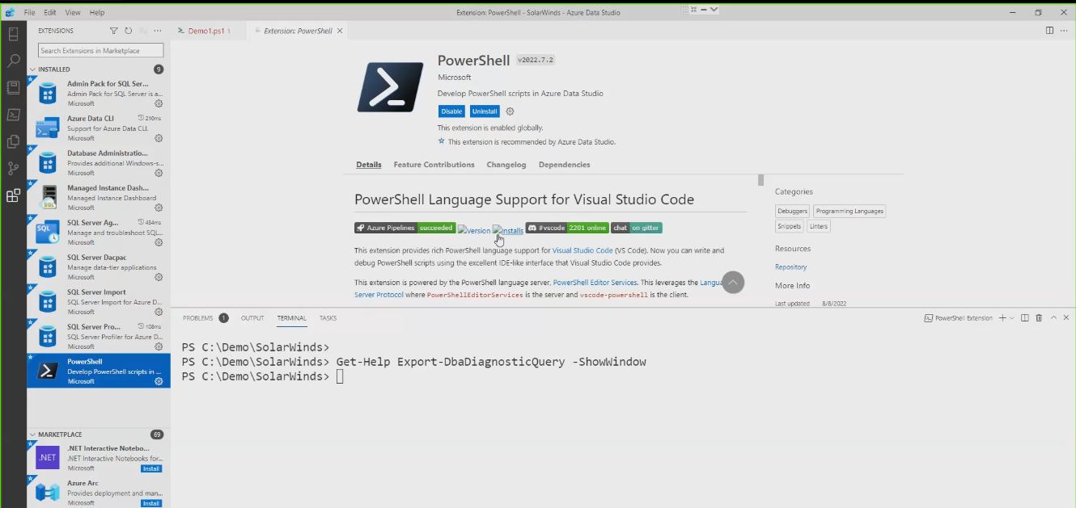
Different shells available [below]
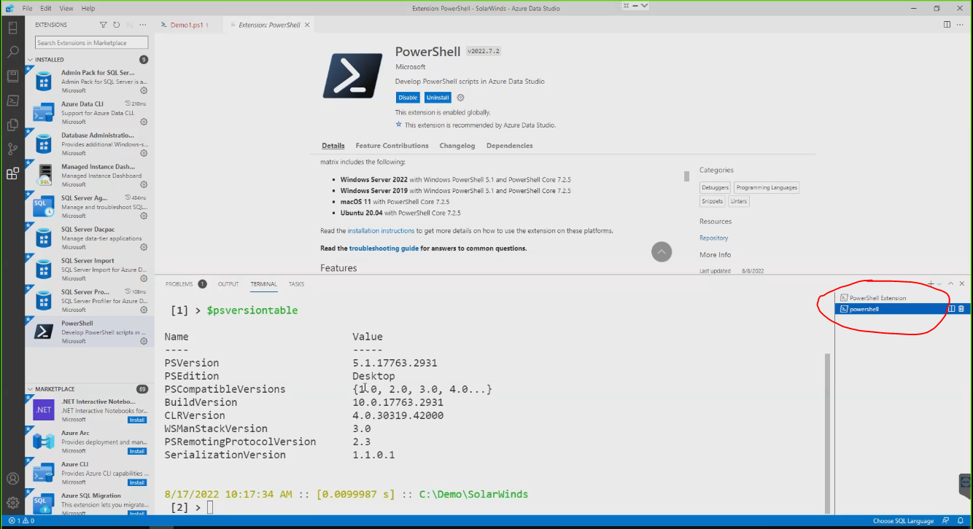
PowerShell ISE is deprecated…memory leaks, etc.

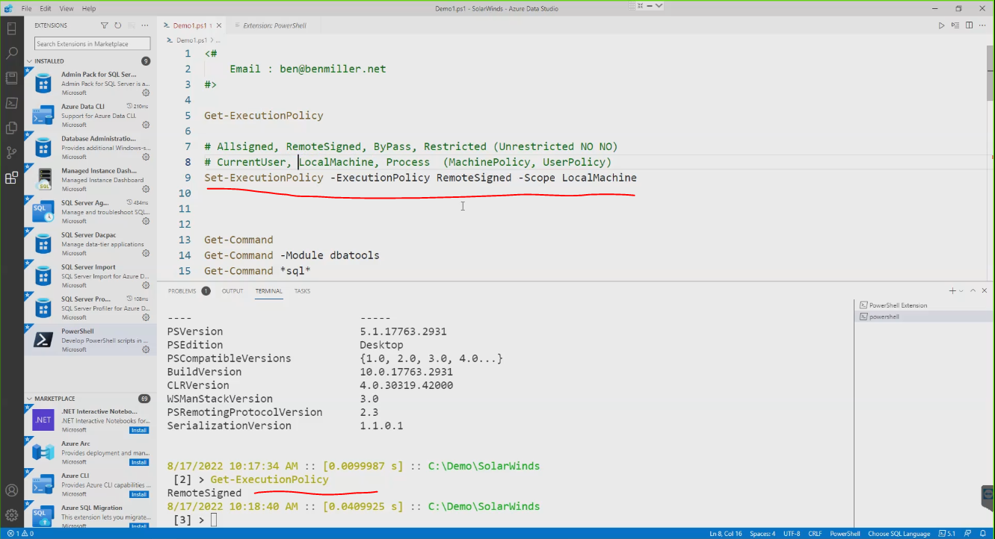
Don’t use “Unrestricted”

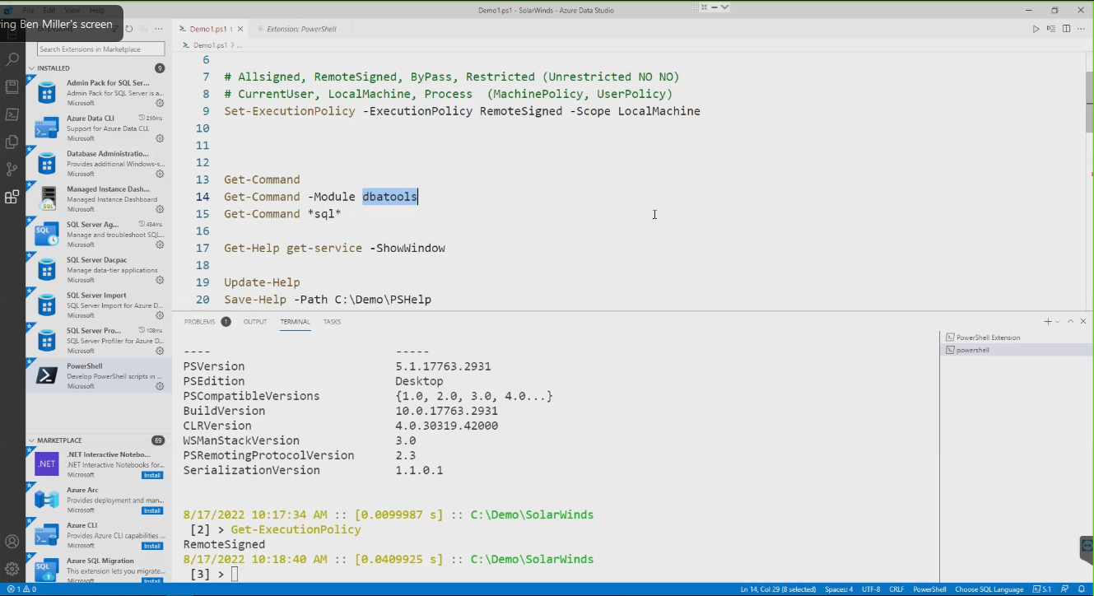
Get-Command -module ___________ actually loads that module.

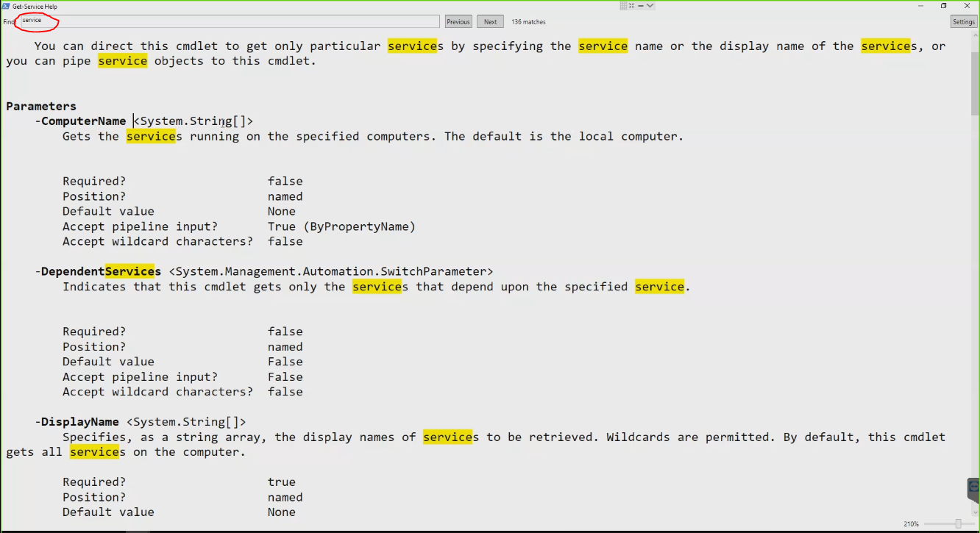
When using the ShowWindow feature. There are settings in the Control menu of the window also.

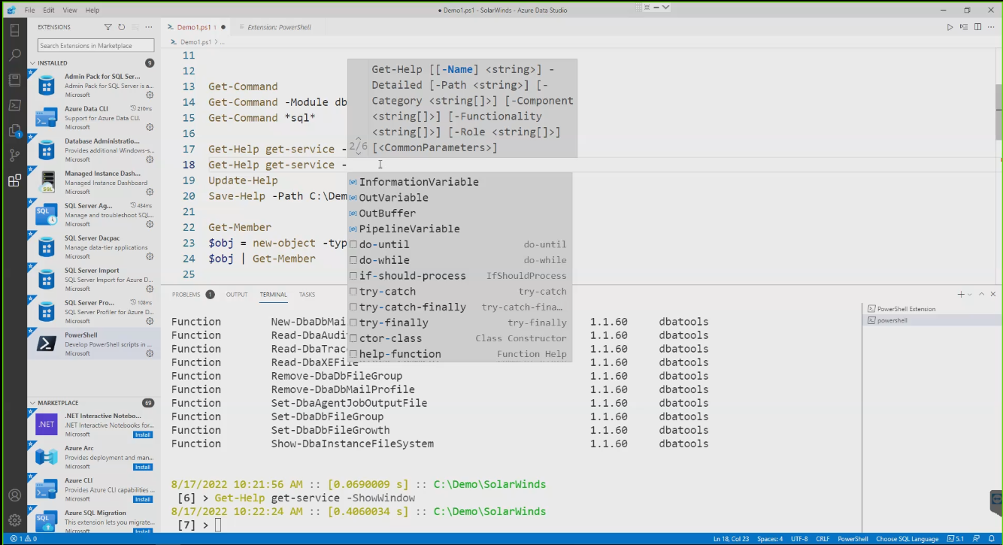
You get some code-writing help in Azure Data Studio.
Square brackets imply an array object.
You can install modules with “-force” (like a Jedi, hehe).
You can “side load” modules as well, the same module with different versions, I think.
When you import a module with maxversion or minversion, and maybe a specific version.
When you install the SQL Server product you get sqlps module.
At 12:40 he talked about a circumstance where you can have a sqlps conflict.

Get-Module -ListAvailable tells you if the module can even be loaded, and it will show available module versions.
Linux can run PowerShell.
In SSMS you can right click on a number of objects and choose “Start PowerShell”.
PowerShell runs on Providers.

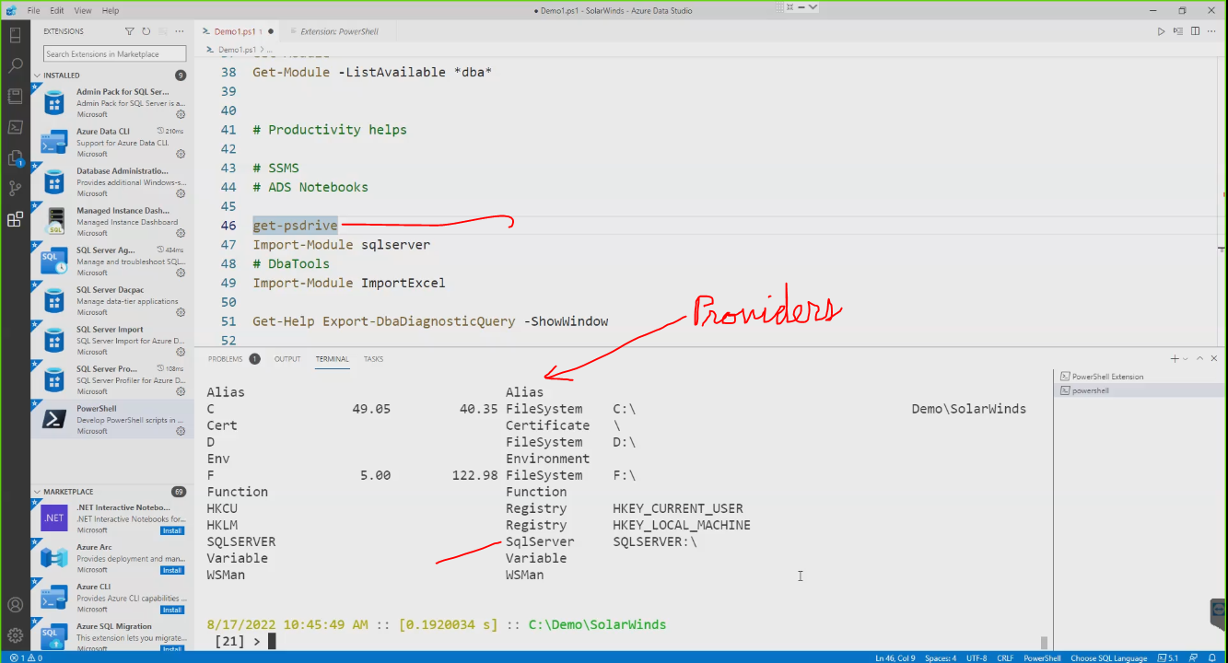

Type and execute $host and it will return what kind of console you have.

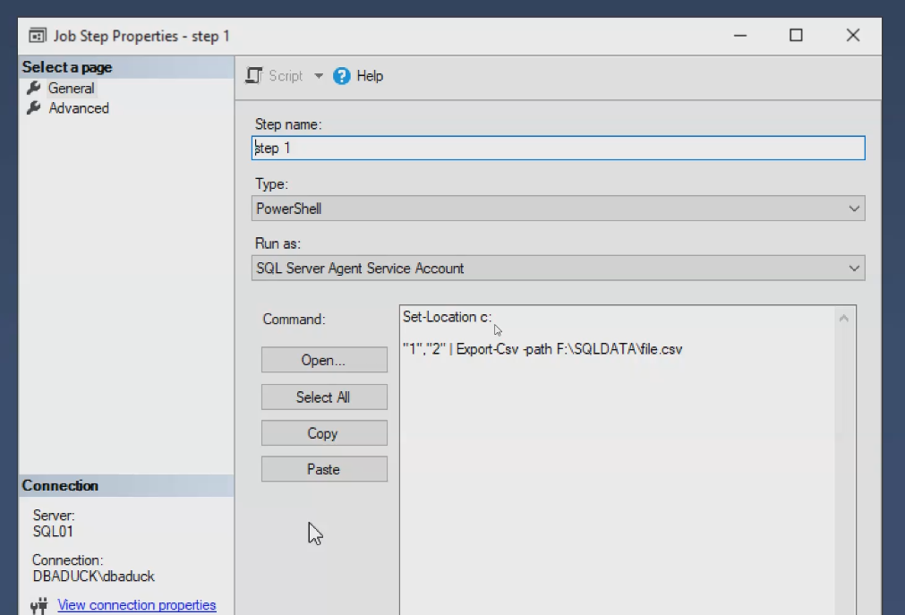
Regarding the SQL Agent you want to set the path (or you may get an unwanted default) at the top of your PowerShell code.

